**ASSIGNMENT 01 – Acquire a Web Host & Domain Name**

Students are required to have access to a Web Host account that they use to create and manage multiple CMS websites. In our first IT320 class, during class we did Activity 01, and we signed up for a shared web host account. In this assignment, you will record information about these accounts and verify that our new shared web host account has an “admin” email account for its domain.  
  
Additionally, we will do a few PHP problems, to test your understanding of the PHP material we covered in class.   
If you have difficulties completing this assignment, please inform the instructor and consider working with DePaul tutors.

**Instructions for completing template:***Replace* **[bracketed red text]** *with the requested information and change the* ***red text to black text.*** *Do not include full screen shot images, or full screen shots that are reduced in size. Use a snippet tool to capture parts of the screen and insert those images into the template.  
Please answer all questions.***Please do not alter template numbering.**

**PART A – Student & Assignment Information**

**1. Student Name: [Abel Marin] [A01]**

**2. Student Contact Information:   
[marinabe1416@gmail.com] [A02]  
[(630) 608-8570] [A03]**

**Go back to the instructions and begin working on part B.**

**Part B – Shared Web Host Information**

1. Which shared web host account did you establish? Please list their name below.  
 [SiteGround] **[B01]**

**Part C – Student Shared Web Admin Email Account Check**

Most shared web hosts use Softaculous build scripts. These scripts are not the same as building WordPress form the Automatic (the company that owns WordPress) default build script.   
One of the default Softaculous options is the “admin email”.  
Softaculous has a default value of admin@“your doimain name”.  
So for your WordPress sites to build and work properly, your web host account must have this default email account. In the tutorial we checked and made one.   
  
In this part of the assignment, I want you to provide proof that the admin email account exists.   
Pantheon users can skip this part without losing any points.

1. Does your new web host account have an email account named “admin”?   
 [Yes] **[C01]  
I’m asking if there is an email account named “admin”, [admin@yourdomain]?  
[For Pantheon – Put Pantheon-YES]** 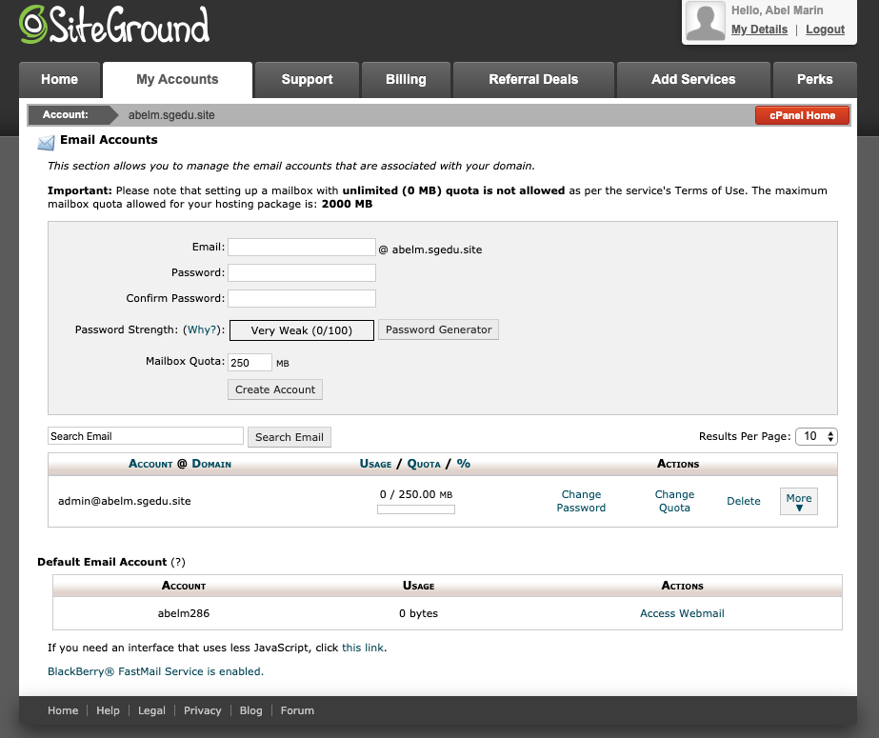

**2. Did you create a forwarder email account**[Yes] **[C02]**

] **[C03]**

**Go back to the instructions and begin working on part D.**

**Part D - PHP Questions and Answers:**

1. This question has two parts.   
   Part 1: Of the following PHP variables, which are valid and which are invalid? Part2: **If the variable is invalid, please list why it is invalid?  
   (HINT: there may be more than 1 error on the variable)**

|  |  |  |  |
| --- | --- | --- | --- |
| **No.** | **Variable** | **Is Valid (Yes/No)** | **If invalid, reason(s) why** |
| **[D01]** | $myNameIsBill | **Yes** |  |
| **[D02]** | **$#name-first** | **No** | **Contains # and - which are not allowed** |
| **[D03]** | **$name_first** | **Yes** |  |
| **[D04]** | **$name-first** | **No** | **Contains a - which is not allowed** |
| **[D05]** | **$ lostAmount** | **Yes** |  |

**2.** Write PHP code that defines a PHP variable named $cost and assigns the $cost variable the value of 5.01 and then in another (different) PHP statement **use the echo function to display the $cost variable**.

|  |
| --- |
| **[D06]** |
| $cost = 5.01;  echo $cost; |

**Go back to the instructions and begin working on part E.**

**Part E – Questions** about IT320 and WordPress CMS

1. Does this class have a midterm exam, final exam, or final project?[No] **[E01]**
2. What should you do to prepare for an IT320 class each week before I watch the tutorial videos? [Read over the presentations] **[E02]**
3. What form should I fill out and send to the instructor when I find a bug or typo in a presentation, tutorial, or assignment?   
   [Bug Reporting for Extra Credit (BRECT) form] **[E03]**
4. Are the tutorials required in this class?

[Yes] **[E04]**

1. Are the assignments required in this class?

[Yes] **[E05]**

1. Do I need a shared web host like SiteGround account to take this class? [Yes] [**E06]**
2. Do I need a Codeanywhere account to take this class? [Yes] **[E07]**
3. There are only two permitted file types you can upload to D2L for this class.   
   What are the two permitted file formats (types) you can submit to D2L for this class? [Microsoft Word and/or PDF] **[E08]**

**Go back to the instructions and begin working on part F.**

**Part F - Assignment - Wrap Up:**

1. **Did you have any problem or issues completing this assignment besides time management issues:   
   [No] [F01]**  
   If you answered yes to this question, please elaborate and be specific.  
   If you had trouble with a specific question, please identify it by number and explain what you did not understand or had problems with.  
   I can only improve this assignment with your help.

**If you have questions or issues about this assignment please contact the instructor immediately.**   
Michael H Chase  
Mobile: 847-878-6225  
Office: 312-362-1352  
Email: [mchase2@cdm.depaul.edu](mailto:mchase2@cdm.depaul.edu)

Submit your completed template to D2L dropbox for assignment 01.

If you prefer not to navigate by hand to the D2L dropbox, take advantage of the dropbox link in the D2L Module 01 Assignment 01 section. This link will take you to the correct assignment dropbox location.